**User Manual**

Table Contents

1. Summary
2. Multiplayer set up
3. How to play
4. Rules
5. Bugs and fixes

**Summary**

It is known worldwide as a pencil and paper game which dates from World War I. It was published by various companies as a pad-and-pencil game in the 1930s, and was released as a plastic board game by Milton Bradley in 1967.

 Simple but fun, both kids and adults are sure to enjoy playing this strategy game!

**Multiplayer Set up**

To set up multiplayer:

1. Open up the game twice on the same computer
2. 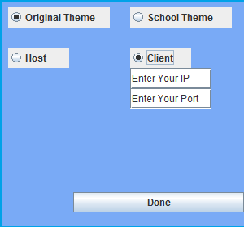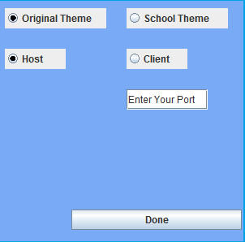Player 1 will need to first host a game and enter the port number then press “enter” on the keyboard
3. Player 2, after player 1 hosts the game, will press client and enter in the IP Address and press “enter” then they will enter the same port number as host and press “enter”
4. When both players are done typing in the necessary information the host will press “Done” first followed by the client pressing “Done” after
5. Now you have set up a multiplayer network

**How to Play**

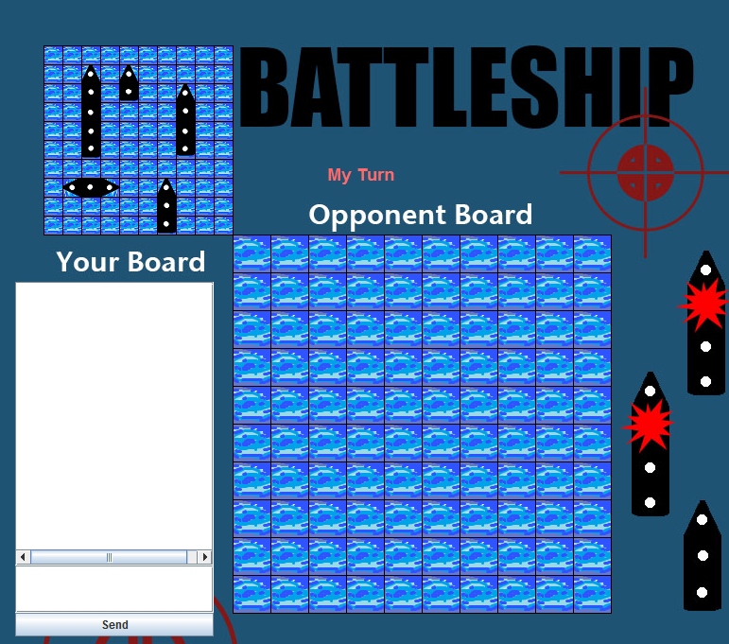The game is played on four [grids](http://en.wikipedia.org/wiki/Grid_(spatial_index)), two for each player. The grids are 10×10 and the individual squares in the grid are identified by letter and number. On one grid the player arranges ships and records the shots by the opponent. On the other grid the player records his/her own shots.

Before play begins, each player secretly arranges their ships on their primary grid. Each ship occupies a number of consecutive squares on the grid, arranged either horizontally or vertically. The number of squares for each ship is determined by the type of the ship. The ships cannot overlap (i.e., only one ship can occupy any given square in the grid). The types and numbers of ships allowed are the same for each player.

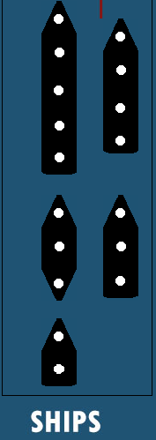

|  |  |
| --- | --- |
| **Type of Ship** | **Size** |
| Aircraft Carrier | 5 |
| Battleship | 4 |
| Submarine | 3 |
| Destroyer | 3 |
| Patrol Boat | 2 |

1. Click on the ships to identify which one you want to place on the board.
2. Move the ships onto the board by clicking and dragging them to desired co-ordinates
3. Rotate the ship by pressing the left and right arrow keys.
4. Click on the play button the start the game. Both players must press this button before the game starts.
5. Click on the co-ordinates the want to aim and fire.
6. If the missile hits, the player would see an explosion; If the missiles misses, it will show ripples

MISS MARKS

HIT MARKS

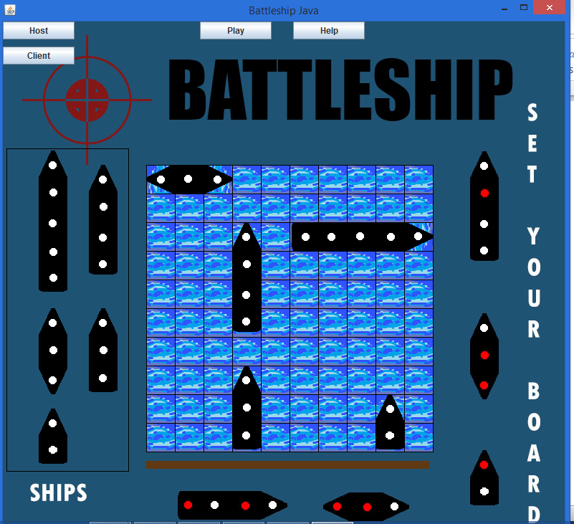



**Rules**

1. Arrange your ships on “YOUR SHIPS” grid according to “FLEET” table
2. Take turns firing a missile at your enemy, by clicking on the opponent’s board which will fire a missile
3. 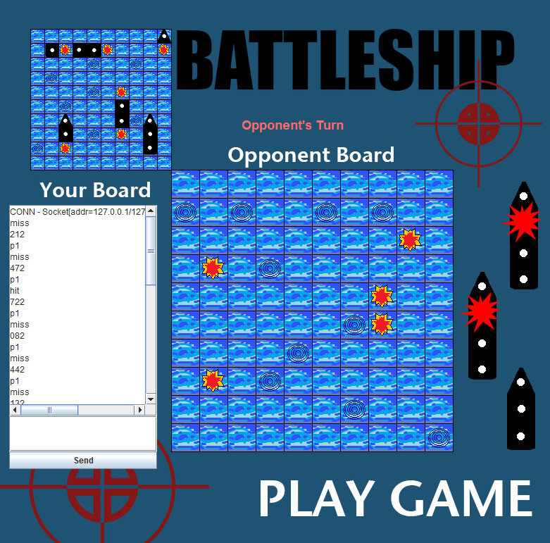 Mark missile fired on “ENEMY SHIPS” grid you must call out when your ship is completely sunk
4. Sink ‘em all

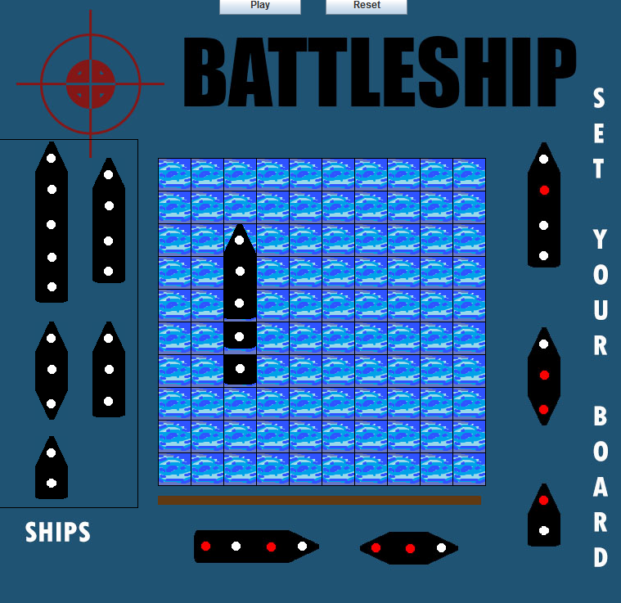**Bugs and Fixes**

Multiple ships have been selected at once

Bug

* The program may lag
* When placing the ships down if you accidentally select a second ship before placing down the ship you are already holding both ships will appear on your mouse and you will drag around both ships
* Also if you place down a ship you cannot pick it back up

Fixes

* For the lag you just have to be patient
* To fix the ship placement bugs you will just need to press on to the right button on the top named “Reset”